***Power On***

The transmitter frequency is pre-set to 433.920 MHz. Please check to make sure that the callsign is programmed. Attach the RF antenna, apply power, and place the unit with a CLEAR VIEW of the sky so the GPS receiver can acquire a lock on the necessary satellites. It may take up to 20 minutes for the GPS to initially lock. Prior to lock, the device will only transmit once per minute. Once lock is obtained, the current position will be transmitted. At the user defined rate (once every 5 seconds by default). It will continue to transmit the last valid position received should it lose lock.

***Pinout Diagram***

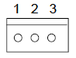(looking down from above)

Pin 1: Battery – (Ground)

Pin 2: Battery +

Pin 3: N/C

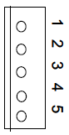

(looking down from above)

Pin 1: TTL level transmit data out (ICSP_DCLK)

Pin 2: TTL level receive data in (ICSP_DATA)

Pin 3: Ground

Pin 4: 3.3V (output of voltage regulator)

Pin 5: MCLR

***Data Storage***

The current version of the 70cm BigRedBee GPS contains a 1-mbit non-volatile memory chip used to store position data. Each “record” is approximately 15 bytes long and stores latitude, longitude, altitude, GPS time, and number of satellites in view. This allow for approx. 2.5 hours of continuous recording at 1 hz.

If “Overwrite Memory on Powerup” is selected, the device will start writing at location 0 when power is applied. If power is cycled, the previously stored data will be overwritten. The “Wrap Data Log” options controls what happens when the end of the memory is reached.

1) Wrap Data Log = Off. Writes start at location 0 when power is applied. Recording stops when the end of memoryis reached.

2) Wrap Data Log = On. Writes start at location 0 when power is applied. Recording wraps around to the beginning when the end of reached. When the wrap occurs, the old data is overwritten with the new data.

Using mode 1) requires that your flight occur within 2.5 hours of applying power before recording stops. Using mode 2) requires that you retrieve the device and turn power off within 2.5 hours of the start of the flight before the data is overwritten.

When using either of these methods be careful about turning the unit on if it contains un-read data. Data will be overwritten once GPS lock is acquired, so apply power and read the device as quickly as possible to prevent data from being overwritten.

If “Overwrite Memory on Powerup” is cleared, the device will keep track of the last address written to, and start writing to that address after power is applied. The “clear flash” button will reset this last address pointer to 0

3) Wrap Mem = OFF. Starts writing at location 0, and picks up where it left off if power is cycled. Stops when it reaches the end of memory. Once the end of memory is reached, No more data will be written until the “clear flash” function is executed.

4) Wrap Mem = On. Starts writing at location 0, and picks up where it left off if power is cycled. Wraps to the beginning when the end is reached. “Clear Flash” will reset the last location pointer to 0.

It is very important to “Clear Flash” prior to use if configured in mode 3). Failing to clear the flash from a previous session will likely mean that no data will be written.

The default configuration is “Overwrite Memory on Powerup” set, and “Wrap Data Log” cleared. In this mode, the device will store data for approx. 2 ½ hours starting at location 0 and stop when memory is filled. While it is recommended that the flash be cleared in between flights, there is no requirement to do so when configure in this mode.

***Post Flight Data Acquisition***

* Preferably do not unplug GPS until data has been extracted.
* Click on read flash (can take up to 5 minutes)
* Save the file to a safe location
* Open .kml file with notepad or google earth

***Troubleshooting***

If the APRS software is decoding odd symbols or only transmitting once a minute, the gps most likely does not have a satellite connection. Make sure GPS has a line of sight view to the sky, so that it can acquire a satellite connection. If the LED is blinking at 1 Hz on the gps, then it should be transmitting valid data. Be careful because the gps will report its last known GPS location if it ever loses satellite connection. You can tell when this happens because the data will report a /- instead of a /*.

***Beeline Communicator***

This WINDOWS ONLY application is used to modify the transmit characteristics stored in flash on the BigRedBee GPS. BeeLine GPS firmware versions 211 and later only respond to input commands shortly after poweron. The procedure below will work for ALL versions, but step #5 is REQUIRED for versions 211 and later.

1) Remove all cables from the Beeline, and unplug the battery

2) Plug the USB interface into your PC’s USB port

3) Start the windows application, and select the appropriate COM port.

4) Apply power to the BigRedBee GPS transmitter, and plug the 5-pin header from the USB interface into the transmitter

5) Wait until you see the LED on the transmitter blink three times.

*6)* Click on “READ”

Note: - It is recommended that you issue a read command before a write.

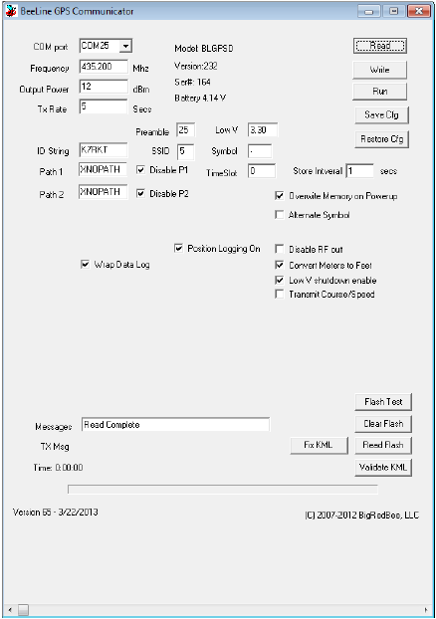

* **Com port**: Set the proper serial port. If you need a com port # that is not available in the drop-down menu, simply type the desired value into the text box.
* **Frequency**: This is the RF carrier frequency the packet will be sent out on. Possible values are 420-450 Mhz
* **Output Power**: Set between -10 dBm and 12 dBm
* **TX Rate**: Number of seconds between packet transmissions
* **Store Interval:** Number of seconds between writes to on-board memory
* **Preamble:** Number of IDLE bits sent before start of packet data, recommended value is 25
* **TimeSlot:** Number of seconds to delay if slotting is enabled.
* **ID String**: Your amateur radio callsign. Not more than 6 characters in length
* **SSID:** The SSID in the APRS packet. The default is 1, possible values are 1 thru 15
* **Symbol:** The symbol character in the APRS packet. The default is ‘-‘
* **Position Logging On**: Position and altitude data will be logged into o-board memory.
* **Enable Slotting:** Turn Time Slotting ON. See below
* **Enable Course/Speed**: The coarse and speed are transmitted as part of the data packet
* **Disable RF Out**: Disables RF transmissions
* **Wrap Data Log**: When set, data is overwritten starting at the beginning after the end is reached.
* **Path**: Each is 7 characters in length. If you’re not familiar with AX-25 digipeating protocols, it’s best to leave these values alone. Placing an ‘X’ in the first character of the first path will eliminate the path from the transmitted packet.
* **Low V Shutdown Enable**: Set this option if you whish the microcontroller to shut down the transmitter and GPS when the voltage gets below the value you set in “Low V”.
* **Low V**: See above
* **Time:** Time (in seconds) since power has been applied. Certain internal events may cause the timer to be reset.
* **Read Flash:** Data memory is read from the BeeLine GPS and stored to disk in the working directory in a file called beegps.kml. If the file exists, an error is displayed. The .kml file is an ascii file with headers and footers designed to be compatible with Google Earth.
* **Clear Flash:** Erases the on-board flash memory
* **Flash Test:** Does a quick write/read of flash memory.